**ДАНА КЕНДЫБАЕВА LAB3**

**create database** lab3;  
**create table** countries  
(  
 **country_id serial primary key**,  
 **country_name varchar**(50),  
 **region_id int**,  
 **population int**);  
**insert into** countries (**country_name**, **region_id**, **population**) **values** (**'Wonderland'**, 3, 5000);  
**insert into** countries (**country_name**) **values** (**'Korea'**);  
**insert into** countries (**region_id**) **values** (**null**);  
**insert into** countries (**country_name**, **region_id**, **population**) **values**

(**'USA'**, 34, 67000),

(**'France'**, 56, 57000),

(**'Malaysia'**, 23, 43900);  
**alter table** countries **alter country_name set default 'Kazakhstan'**;  
**insert into** countries (**region_id**, **population**) **values** (45, 170000);  
**alter table** countries **alter region_id set default** 66, **alter population set default** 358890;  
**insert into** countries (**country_name**, **region_id**, **population**) **values**(**default**, **default**, **default**);  
  
**select** *\** **into** countries_new **from** countries;  
**update** countries_new **set region_id** = 1 **where region_id is null**;  
**update** countries_new **set population** = **population** * 1.1;  
**select country_name**, **population as** new_population **from** countries_new;  
**delete from** countries_new **where population** < 100000;  
**delete from** countries_new **where** *EXISTS*

(**SELECT** *\** **FROM** countries

**WHERE** countries.**country_id** = countries_new.**country_id**);  
**delete from** countries;

**select** *\** **from** countries;

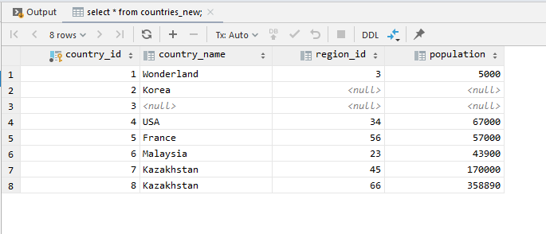  
**select** *\** **from** countries_new;//new population

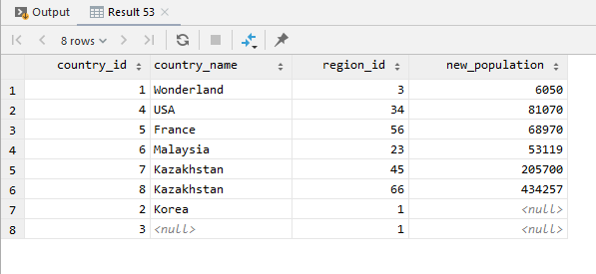

**select** *\** **from** countries_new;//delete rows where population <100k

